**Experiment 03**

**Learning Objective:**

Student should be able to Convert HEX to BCD and BCD to HEX using stack in ALP.

**Tools:** TASM/MASM

**Theory:**

**Software Architecture / Register Set/ Programmer’s model of Intel 8086**

**Microprocessor:**

**GENERAL PURPOSE REGISTERS**

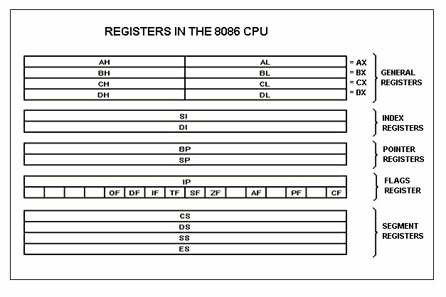8086 CPU has 8 general purpose registers, each register has its own

AX - the accumulator register (divided into AH / AL):

1. Generates shortest machine code
2. Arithmetic, logic, and data transfer
3. One number must be in AL or AX
4. Multiplication & Division
5. Input & Output

BX - the base address register (divided into BH / BL).

CX - the count register (divided into CH / CL):

1. Iterative code segments using the LOOP instruction
2. Repetitive operations on strings with the REP command
3. Count (in CL) of bits to shift and rotate

DX - the data register (divided into DH / DL):

1. DX:AX concatenated into 32-bit register for some MUL and DIV operations
2. Specifying ports in some IN and OUT operations

SI - source index register:

1. Can be used for pointer addressing of data
2. Used as source in some string processing instructions
3. Offset address relative to DS

DI - destination index register:

1. Can be used for pointer addressing of data
2. Used as destination in some string processing instructions
3. Offset address relative to ES

BP - base pointer:

1. Primarily used to access parameters passed via the stack
2. Offset address relative to SS

SP - stack pointer:

1. Always points to top item on the stack
2. Offset address relative to SS
3. Always points to word (byte at even address)
4. An empty stack will have SP = FFFEh

**SEGMENT REGISTERS**

CS - points at the segment containing the current program.

DS - generally points at segment where variables are defined.

ES - extra segment register, it's up to a coder to define its usage.

SS - points at the segment containing the stack.

 Flag Register of 8086:

* A flag is a flip-flop which indicates some condition produced by the execution of an instruction or controls certain operations of the EU.
* The Flag Register is a special register associated with the ALU.
* A 16-bit flag register in the EU contains nine active flags.
* Fig. shows the location of the nine flags in the flag register

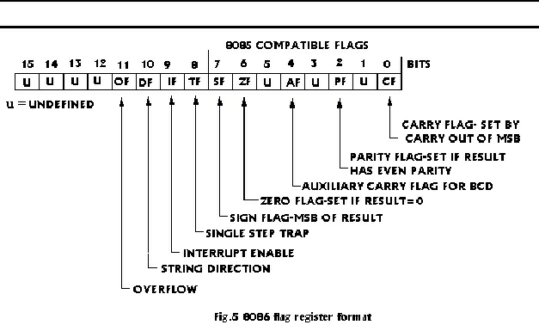**Fig. 1.4 Flag Register structure**

Flags is a 16-bit register containing 9 1-bit flags:

* Overflow Flag (OF) - set if the result is too large positive number or is too small negative number to fit into destination operand.
* Direction Flag (DF) - if set then string manipulation instructions will auto-decrement index registers. If cleared, then the index registers will be auto-incremented.
* Interrupt-enable Flag (IF) - setting this bit enables maskable interrupts.
* Single-step Flag (TF) - if set then single-step interrupt will occur after the next instruction.
* Sign Flag (SF) - set if the most significant bit of the result is set.
* Zero Flag (ZF) - set if the result is zero.
* Auxiliary carry Flag (AF) - set if there was a carry from or borrow to bits 0-3 in the

AL register.

* Parity Flag (PF) - set if parity (the number of "1" bits) in the low-order byte of the result is even.
* Carry Flag (CF) - set if there was a carry from or borrow to the most significant bit during last result calculation.

**Procedure to Convert 4-digit Hex number to its equivalent BCD number**.

We have a 4-digit Hex number whose equivalent binary number is to be found i.e. FFFF H. Initially we compare FFFF H with decimal 10000 (2710 H in Hex). If number is greater than 10,000, we add it to DH register. Also, we subtract decimal 10,000 from FFFF H, each time comparison is made. Then we compare the number obtained in AX by 1000 decimal. Each time we subtract 1000 decimal from AX and add 1000 decimal to BX. Then we compare number obtained in AX by 100 decimals. Each time we subtract 100 decimals from AX and add 100 decimals to BX to obtain BCD equivalent. Then we compare number obtained in AX with 10 decimals. Each time we subtract 10 decimals from AX, and we add 10 decimals to BX. Finally, we add the result in BX with remainder in AX. The result is present in register DH with contains the 5th bit if present and registers AX. Display the result.

**Algorithm:**

Step I: Initialize the data segment.

Step II: Initialize BX = 0000 H and DH = 00H.

Step III: Load the number in AX.

Step IV: Compare number with 10000 decimals. If below go to step VII else go to Step V.

Step V: Subtract 10,000 decimal from AX and add 1 decimal to DH

Step VI: Jump to step IV.

Step VII: Compare number in AX with 1000, if below go to step X else go to

Step VIII: Subtract 1000 decimal from AX and add 1000 decimal to BX.

Step IX: Jump to step VII.

Step X: Compare the number in AX with 100 decimals if below go to step XIII

Step XI: Subtract 100 decimal from AX and add 100 decimals to BX.

Step XII: Jump to step X

Step XIII: Compare number in AX with 10. If below go to step XVI

Step XIV: Subtract 10 decimal from AX and add 10 decimals to BX.

Step XV: Jump to step XIII.

Step XVI: Add remainder in AX with result in BX.

Step XVII: Display the result in DH and BX.

Step XVIII: Stop.

**Application: Conversion of HEX to BCD and BCD to HEX.**

**Design:**

**Result and Discussion:** 

.MODEL SMALL

.STACK

.DATA

M1 DB 10, 13, "HEX TP BCD IS : $"

NO DW 0FFFFH

.CODE

DISP MACRO XX

MOV AH, 09

LEA DX, XX

INT 21H

ENDM

.STARTUP

DISP M1

MOV AX, NO

MOV DH, 0

MOV BX, 0AH

MOV CL, 0

BACK:

MOV DX, 0

DIV BX

PUSH DX

INC CL

CMP AX, 0

JNZ BACK

BACK1:

POP DX

ADD DL, 30H

MOV AH, 02

INT 21H

DEC CL

JNZ BACK1

.EXIT

END

**Output:**

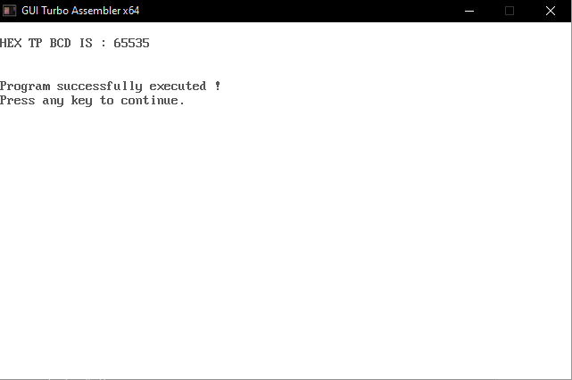

**Learning Outcomes:**

The student should have the ability to

LO1: Draw and explain the format of PUSH and POP instructions.

LO2: Explain the concept of Number systems.

LO3: Apply stack instructions to convert HEX to BCD and BCD to HEX.

**Course Outcomes**:

Upon completion of the course students will be able to make use of instructions of 8086 to build assembly and Mixed language programs.

**Conclusion:**

For Faculty Use

|  |  |  |  |  |
| --- | --- | --- | --- | --- |
| **Correction Parameters** | **Formative Assessment [40%]** | **Timely completion of Practical [ 40%]** | **Attendance / Learning Attitude [20%]** |  |
| **Marks Obtained** |  |  |  |